CAPTAIN’S INVITATIONAL

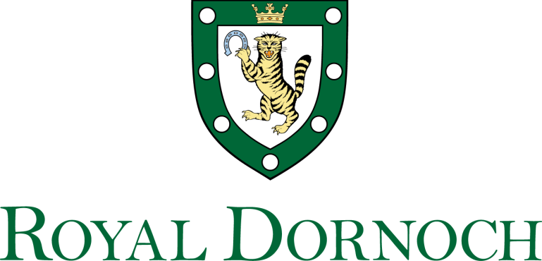
SATURDAY 21st MAY 2022
Ladies and Gents 2 Person Texas Scramble Stableford
Struie Course 7.00am - 3.00pm

1 | 7.00
2 | 7.10
3 | 7.20 | Matthew Barger & Pete Higgins | 38 | Jason Fish & Richard Holstrom | 41
4 | 7.30 | Peter Alderson & Les King | 36 | Matt Cole & Trent Hoover | 43
5 | 7.40 | Erickson Davis & Rusty Hill | 39 | David Fleming & William Moffat | 41
6 | 7.50 | Alex Greene & Robert Stephens | 41 | Michael Meehan & Graham Klintworth | 37
7 | 8.00 | Ian McAuley & Daniel Bladen | 43 | Arnie Peinado & John Willian | 27
8 | 8.10 | George Cooper & Kenneth Walker | 16 | Harry Winther & Thomas Gibbs | 35
9 | 8.20 | Angus Winther & Charles Gibbs | 37 | Kevin Fenelon & Richard McGrail | 40
10 | 8.30 | Steve Woodward & Brett Berthold | 33 | Trey Wilkinson & Alan Edgin | 38
11 | 8.40 | Sean Cusick & Joe Benz | 41 | Malcolm Maccoll & Tommy Bryson | 38
12 | 8.50
13 | 9.00 | Jamie Cooper & Alan Smith | 39 | Mike Brooks & Ken Barker | 41
14 | 9.10 | Ed Chabay & Ben Murray | 36 | Kenneth Houston & Thomas Smith | 43
15 | 9.20 | Henry Kitchener & David Anson | 33 | James Pearson & Philip Pearson | 38
16 | 9.30 | Jim Loy & Stuart Hall | 36 | Chris Dyson & Alec Stoner | 38
17 | 9.40 | James Rogers & William Hutchison | 40 | Edward Steel & Jim Redfern | 41
18 | 9.50 | Chris Cumminskey & David Losin | 35 | Jo Dyson & Andy Orrey | 42
19 | 10.00 | Scott Ehlen & Nick Ehlen | 33 | Rob Murray & Robin Fulton | 37
20 | 10.10 | Peter Munro & Graham Bradley | 36 | David Bell & Andrew Stevenson | 39
21 | 10.20 | Andrew MacWilliam & Steve Dimitriou | 37 | Alastair Davidson & Jeff Butcher | 36
22 | 10.30 | Alan Coutts & Eric Brown | 42 | Wilma Murray & Carol Fulton | 32
23 | 10.40 | Martjan van der Knoop & David Snodgrass | 36 | Roddy McEwan & Colin McKenna | 37
24 | 10.50 | James Elliott & Gordon Grant | 36 | Lynda Robertson & Nadia Robertson | 32
25 | 11.00 | Alex Elliott & Murray Elliott | 31 | Charles Rumbles & Donald Gunn | 41
26 | 11.10 | Daniel Ladenberger & Keith Kimberlin | 41 | Bob Robertson & Tom Schofield | 40
27 | 11.20 | Robert Peake & Mark Lawrence | 34 | Suzanne Kidd & Gill Williams | 34
28 | 11.30 | Neil McQueen & Andrew Gee | 41 | Jane Neville & Rosie Dennis | 30
29 | 11.40
30 | 11.50 | Tim Lohmann & Joseph Lo | 42 | Jonathan Kidd & Richard Lister | 39
31 | 12.00 | Doug Neville & Martin Dennis | 40 | Robert Crowder & Tim Johnson | 37
32 | 12.10 | Sarah Lohmann & Bohwon Kim | 34 | Chris Day & Michael Elysee | 37
33 | 12.20 | Louis Bovis & David Schofield | 32 | Donald MacKenzie & Jan Gray | 33
34 | 12.30 | Gary Moore & Andrew Heron | 39 | Marina Masson & James O’Hagan | 30
35 | 12.40
36 | 12.50 | Eddie Hughes & Derek Hyndman | 36 | David Bone & Fraser Bone | 37
37 | 13.00 | Mark Johnson & David Peel | 40 | Mark Kingston & Rob Coates | 35
38 | 13.10 | Grant Shannon & Stuart Orr | 30 | Marjorie Kingston & Hope O’Neill | 30
39 | 13.20
40 | 13.30 | Willie Mackay & David Burland | 35 | Michael Pytosh & Matthew Harblin | 34
41 | 13.40 | Vincent Doyle & Gordon Weir | 40 | Pim Verschueren & Mark Combes | 34
42 | 13.50 | Larry Coben & Terry O’Toole | 35 | Cath Rawthore & Naeem Ahmed | 44
43 | 14.00 | Fiona Hampton & Jason Kelman | 39 | Mobishir Rawthore & Amjad Butt | 44
44 | 14.10 | James Boyce & Grant Richards | 39 | Nigel Morecroft & Les Steel | 42
45 | 14.20 | Richard McGraw & Bob Perry | 38 | Simon Scott & Julian Slade | 41
46 | 14.30 | Greg Ryan & Chris Carlton | 31 | Adam Preedy & Colin Neilson | 39
47 | 14.40
48 | 14.50
49 | 15.00

