CAPTAIN’S INVITATIONAL

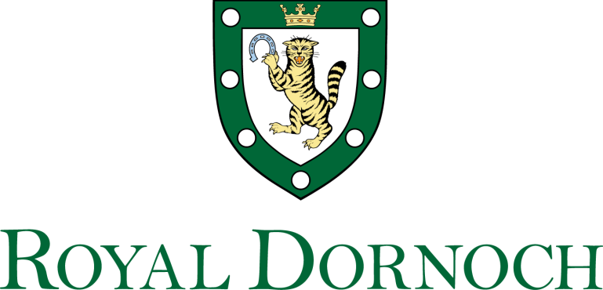
SUNDAY 22nd MAY 2022
Ladies and Gents Greensomes Stableford
Championship Course 7.00am - 3.00pm

1 | 7.00 | Matthew Barger & Pete Higgins | 31 | Alex Elliott & Murray Elliott | 38
2 | 7.10 | Mark Johnson & David Peel | 32 | James Elliott & Gordon Grant | 33
3 | 7.20 | Louis Bovis & David Schofield | 28 | James Pearson & Philip Pearson | 28
4 | 7.30 | Greg Ryan & Chris Carlton | 28 | Alex Greene & Robert Stephens | 32
5 | 7.40 | Neil McQueen & Andrew Gee | 27 | Chris Dyson & Alec Stoner | 35
6 | 7.50 | Gary Moore & Andrew Heron | 31 | Jo Dyson & Andy Orrey | 35
7 | 8.00 | Angus Winther & Charles Gibbs | 38 | Sean Cusick & Joe Benz | 35
8 | 8.10 | Harry Winther & Thomas Gibbs | 36 | Erickson Davis & Rusty Hill | 33
9 | 8.20 |  |  | Nigel Morecroft & Les Steel | 40
10 | 8.30 | Kenneth Houston & Thomas Smith | 31 | George Cooper & Kenneth Walker | 24
11 | 8.40 | Arnie Peinado & John Willian | 31 | Matt Cole & Trent Hoover | 27
12 | 8.50 | Ed Chabay & Ben Murray | 33 | Mike Brooks & Ken Barker | 38
13 | 9.00 | Donald Mackenzie & Jan Gray | 37 | Charles Rumbles & Donald Gunn | 30
14 | 9.10 | David Fleming & William Moffat | 33 | Jamie Cooper & Alan Smith | 37
15 | 9.20 | Kevin Fenelon & Richard McGrail | 34 | Malcolm MacColl & Tommy Bryson | 33
16 | 9.30 | David Bell & Andrew Stevenson | 37 | Wilma Murray & Carol Fulton | 35
17 | 9.40 | Rob Murray & Robin Fulton | 29 | Jim Loy & Stuart Hall | 35
18 | 9.50 | Scott Ehlen & Nick Ehlen | 33 | Andrew Macwilliam & Steve Dimitriou | 30

19 | 10.00 | Chris Cumminskey & David Losin | 23 | Trey Wilkinson & Alan Edgin | 32
20 | 10.10 | Mobishir Rawthorne & Amjad Butt | 37 | Cath Rawthorne & Naeem Ahmed | 35
21 | 10.20 | James Rogers & William Hutchison | 33 | Roddy McEwan & Colin McKenna | 35
22 | 10.30 | Alastair Davidson & Jeff Butcher | 34 | Willie Mackay & David Burland | 33
23 | 10.40 | Eddie Hughes & Derek Hyndman | 36 | Martjan van der Knoop & Lidy van der Knoop | 33
24 | 10.50 | Alan Coutts & Eric Brown | 30 | Henry Kitchener & David Anson | 31
25 | 11.00 | Marina Masson & James O’Hagan | 36 | Ian McAuley & Daniel Bladen | 29
26 | 11.10 | Jane Neville & Rosie Dennis | 31 | Tim Lohmann & Joseph Lo | 29
27 | 11.20 | Doug Neville & Martin Dennis | 32 | Sarah Lohman & Bohwon Kim | 35
28 | 11.30 | Adam Preedy & Colin Neilson | 33 | David Bone & Fraser Bone | 27
29 | 11.40 | Robert Peake & Mark Lawrence | 26 | Lynda Robertson & Nadia Rutherford | 32
30 | 11.50 | Daniel Ladenberger & Keith Kimberlin | 36 | Jonathan Kidd & Richard Lister | 33
31 | 12.00 | Simon Scott & Julian Slade | 38 | Rosemary Muschamp & Sue Stead | 33
32 | 12.10 | Robert Crowder & Tim Johnson | 34 | Suzanne Kidd & Gill Williams | 41
33 | 12.20 | Bob Robertson & Tom Schofield | 39 | Marjorie Kingston & Hope O’Neill | 34
34 | 12.30 | Mark Kingston & Rob Coates | 31 | Jason Fish & Richard Holstrom | 38
35 | 12.40 |  |  | Chris Day & Michael Elysee | 39
36 | 12.50
37 | 13.00 | Grant Shannon & Stuart Orr | 25 | Pim Verschueren & Mark Combes | 30
38 | 13.10 | Vincent Doyle & Gordon Weir | 37 | Fiona Hampton & Jason Kelman | 38
39 | 13.20 | David Muschamp & Don Stead | 32 | Michael Pytosh & Matthew Harblin | 23
40 | 13.30 | Larry Coben & Terry O’Toole | 33 | Michael Meehan & Graham Klintworth | 34
41 | 13.40 | James Keene & Elton Hudgins | 28 | Steve Woodward & Brett Berthold | 26
42 | 13.50 | James Boyce & Grant Richards | 30 | Richard McGraw & Bob Perry Jr | 29
43 | 14.00
44 | 14.10
45 | 14.20
46 | 14.30
47 | 14.40
48 | 14.50
49 | 15.00

